WORKSHEET: SAVANNAS
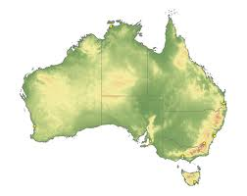
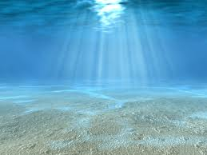
Please solve these logic puzzles and write your answer on the line below:
Savannas
Giraffe’s head
Look 2 C A
AFRSAVANNAICA
Roots
Savanna in Africa
Deeper Roots
Look up to see a Giraffe’s head.
Savannas in/are in Australia
WORKSHEET: SAVANNAS
Please unscramble the following:
- NLOI =
LION
- AONDGERTADI=
DEGRADATION
- BMDAURE=
BERMUDA
- PSHRA=
SHARP
- FARSAIS=
SAFARIS
- LAFLIRAN=
RAINFALL

State True or False to the following statements:
The Lion King is set in the Savanna – T F
Africa is the only country with Savannas – T F
Bermuda grass is also known as Couch Grass – T F
Human Evolution began in Europe – T F
Lions eat Zebras – T F

Answer the following:
Name one place other than Africa where Savannas are found:
SOUTH AMERICA, AUSTRALIA, AND NORTH AMERICA
Name one adaptation plants in the Savanna have undergone:
DEEPER ROOTS, FEWER LEAVES, LOSE LEAVES, WATER STORAGE, SPIKES, POISONOUS SAP, WOOLLY HAIRS, DROUGHT RESISTANT.
WORKSHEET: SAVANNAS
Name one plant native to the Savanna:
BAOBOB TREE, RIVER BUSH WILLOW, BERMUDA GRASS, SENEGAL GUM, CANDELABRA TREE, GUM TREE.
Name one adaptation animals in the Savanna have undergone:
SHARP CLAWS, TRUNKS, TUSKS, SLENDER LEGS, EYESIGHT, TEETH, ENDURANCE, VENOM, FLEXIBILITY, VIBRATIONS, SHARP TEETH, GOOD SENSES, FUR, STRONG JAW, STRONG PAWS.
Name one animal native to the Savanna:
BLACK MAMBA SNAKE, AFRICAN ELEPHANT, AFRICAN WILD DOG, DESERT LYNX, CHACMA BABOON, EGPTIAN MONGOOSE, EMU, LION, KOALA, ZEBRA, NILE CROCODILE, NEGRICEPS ANTS, GIRAFFE, LEOPARDS.

